**Barron’s Math 360: A Complete Study Guide to Geometry**

# Chapter 2: Measure and Congruence

## Measurements of Segments and Angles

We use a *ruler* for measuring the length of a segment and the *protractor* for measuring an angle. In our example, the measure of the angle $ABC$ is 60 degrees. We abbreviate this by writing m∡ $ABC=60$, read as “The measure of angle $ABC$ is 60.” It is customary to omit the degree symbol ($°$). Thus we never write m∡ $ABC=60°$ or $∡ABC=60$ (omitting the “m”).

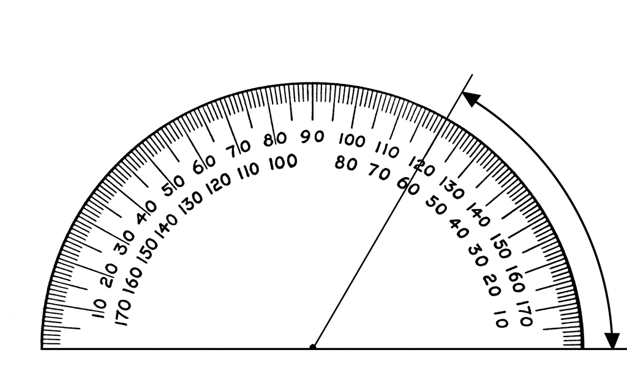

### Classifying Angles

Angles may be classified by comparing their measures to a $90°$ angle. An L-shaped angle is called a ***right angle*** and its measure is exactly equal to $90°$. An angle whose measure is less than $90°$ (but greater than $0°$) is called an ***acute angle***. An angle whose measure is greater than $90°$ (but les than $180°$) is called an ***obtuse angle***. An angle that is exactly $180°$ is called a **straight angle**.

Note: It is customary to denote a right angle by marking a “box” in the corner of the angle as shown above.

## Betweenness of Points and Rays

Paul standing in line with Allan and Barbara

Paul not standing in line with Allan and Barbara

Paul is behind both Allan and Barbara

### Definition of Betweenness

Point $P$ is between points $A and B$ if both of the following are met:

1. Points, $A, P, and B$ are three different collinear points.

$AB=AP+PB$

Condition 1 eliminates the Paul is not in line as a possibility, while Condition 2 eliminates the possibility of Paul is behind both Allan and Barbara.

Note: If m ∡AOP = 40 and m ∡POB = 10, then   
m ∡AOB = 50. This somewhat obvious relationship is given a special name: the Angle Addition Postulate.

**Angle Addition Postulate**

If ray $\vec{OP}$ lies in the interior of angle $AOB$, then $m ∡AOB=m∡AOP+m∡POB$.

## Congruence

Figures that have the same size and shape are said to be congruent. The symbol for congruent is $≅$.

Figures may agree in one or more dimensions yet not be congruent. A square and parallelogram may have 4 sides of equal length, but the figures are not congruent if their corresponding angles are not identical in measure.

A line segment has a single dimension – its length. Two segments are congruent, therefore if they have the same length.

Similarly, if two angles have the same measure, then they are congruent.

Congruence is one of the fundamental concepts of geometry.

**Definition of Congruent Segments Or Angles**

Segments (or angles) are *congruent* if they have the same measure.

## Basic Constructions

Geometric constructions, unlike *drawings*, are made only with a straightedge (for example, an unmarked ruler) and compass. The point at which the pivot point of the compass is placed is sometimes referred to as the *center*, while the fixed compass setting that is used is called the radius length.

### Copying Segments And Angles

Given a line segment or angle, it is possible to construct another line segment or angle that is congruent to the original segment or angle without using a ruler or protractor.

### Midpoint and Bisector

### Definition of a Midpoint

### Definition of a Segment Bisector

### Definition of Angle Bisector